Experiment No. 2-Signal Operations and Transformations
- To perform amplitude scaling and time scaling of continuous-time and discrete-time signals and analyze their effects on signal characteristics.
Output graphs:
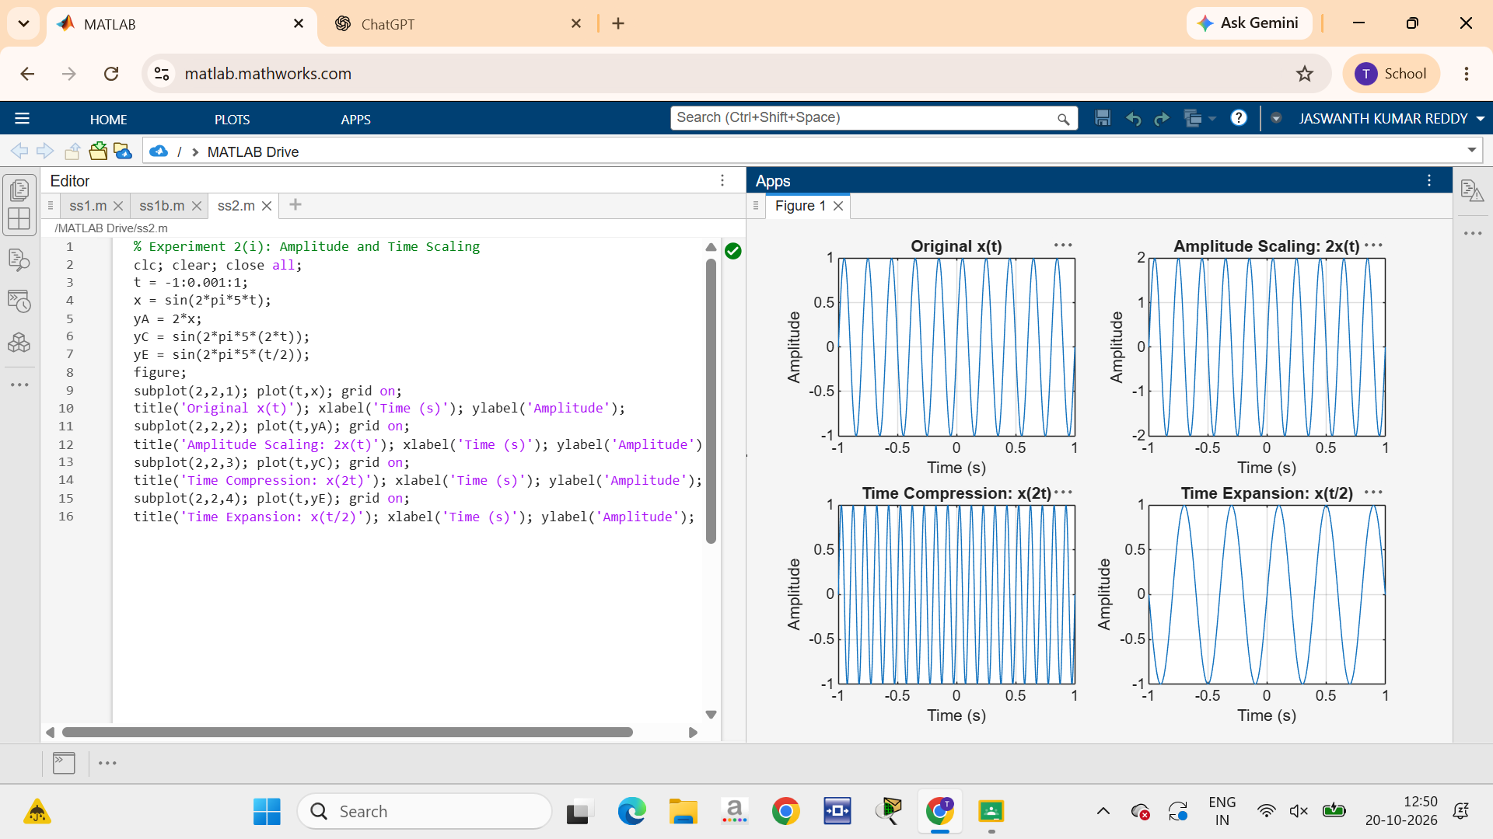
- To perform time shifting and time reversal of continuous-time and discrete-time signals and analyze the resulting transformations.
